

UXC Red Rock

Proposal for

eHealth NSW

RFx name

18th JUN 2015

|  |
| --- |
| Our Core Values |
| **Always seek to delight our customers** |
| **Trusted to do the right thing** |
| **Good enough is not enough** |
| **Listen before talking** |
| **We like to have fun… Seriously!** |



Contents

1 Executive Summary 4

1.1 Enter Content Here 5

Summary 5

2 JDE Capability Overview 6

2.1 Subheading 6

3 Proposed Resources 6

3.1 Subheading 6

3.2 Landscape page for Implementation Plan, etc. 6

4 Pricing 6

4.1 Subheading 6

4.2 Pricing table format 6

5 Section Title 6

5.1 Subheading 6

6 Section Title 6

6.1 Subheading 6

7 Section Title 6

7.1 Subheading 6

8 Section Title 6

8.1 Subheading 6

9 Section Title 6

9.1 Subheading 6

10 Attachment 6

10.1 Subheading 6

11 Attachment 2 6

11.1 Subheading 6

12 Attachment 6

|  |
| --- |
| 1. Executive Summary |



Summary

UXC Red Rock is pleased to provide a Statement of Work (SoW) for the enhancement and support of Business Analytics solution at eHealth NSW. UXC Red Rock began implementing Business Analytics solution for eHealth NSW in March 2013 starting with HR Analytics and since then it has evolved into an Enterprise Data Warehouse paralleling their Stafflink solution in terms of scale and depth. At present Business Analytics solution at eHealth comprises of the following functional areas.

* Human Resources
* Payroll
* Accounts Payable
* Accounts Receivable
* General Ledger
* Procurement and Spend Analytics
* Project Analytics
* Roster System Analysis

In addition to the functional areas mentioned above, Business Analytics solution also serves as the hosted environment for two other reporting streams, namely vMoney and NEPT Reporting. eHealth is looking to further enhance their Business Analytics solution to better align it with their future Analytics strategy and provide a single source of truth for their management reporting needs.

Our objective is to provide eHealth with a quality, low risk, competitively priced enhancement and support solution via our experienced Business Analytics resources. By working in partnership with eHealth NSW business and stakeholders, we will continue to deliver a quality Business Analytics solution for eHealth NSW by focusing on the following key areas:

* Enhancement of HR, Procurement & Spend, Financial and Project Analytics
* Integration of current Business Analytics solution with other reporting solution such as SMR utilising the new Exalytics Hardware
* Business as usual work for the existing solution

|  |  |
| --- | --- |
|  | Partnership  Our engagement approach with eHealth NSW is collaborative. We will partner with eHealth NSW internal stakeholders, working side-by-side to deliver superior value and faster project benefits realisation. |
|  | Leadership, IP and Capability  UXC Red Rock’s mature |
|  | Ability to execute  UXC Red Rock has 10 years’ experience in Business Analytics implementations |
|  | Reduced Risk  As an experienced partner we will provide continuity for the enhancement and business as usual activities. We can also provide a broadly skilled Hyperion Planning and Budgeting team, to augment any resources requirements during the migration to Exalytics hardware. |
|  | Price  Our proposed enhancement and support approach is via a proven methodology. When matched with an experienced UXC Red Rock team we will deliver a cost-effective solution to eHealth NSW on-time and on-budget. |

We believe the combination of the above approach and focus enables UXC Red Rock to deliver a reduced risk Business Analytics solution to eHealth NSW that is cost effective over the long term with a lower TCO. We trust that we have provided the necessary credentials to earn your support and we look forward to the opportunity to work with you.

Yours sincerely,

[Signature here]

[Name]

[Title], UXC Red Rock Consulting

|  |
| --- |
| 1. Business Analytics Capabilities Overview |



* 1. Key Capabilities

The key capabilities that UXC Red Rock are able to leverage to the benefit of eHealth NSW are as follows:

|  |  |
| --- | --- |
|  | Highly Skilled Business Analytics Consulting Team  UXC Red Rock is the largest Oracle Business Analytics consulting organisation in ANZ with over 50 specialist consultants. We were the first Oracle partner in the region to provide a full service offering. Our absolute commitment to technical and service excellence means we have completed more Business Analytics implementations and upgrades than any other regional partner. |
|  | Experienced Business Analytics Development Team  UXC Red Rock can leverage on the experience of wide range of Oracle Business Analytics customisations and our experienced developers can work with you to bridge the gaps between your business requirements and the native Oracle Business Analytics functionality. |
|  | Talented DBA & Infrastructure Services Team  UXC Red Rock has a talented team of Principle DBA consultants that can help ensure that your Oracle Business Analytics infrastructure platform will scale to your business needs, be performant and support all of your security and mobile business requirements. |
|  | Integration Service Function  The UXC Red Rock integration services team engages closely with the UXC Red Rock Oracle Business Analytics team, and DBA consulting teams to deliver a range of end to end integration solutions. |
|  | Offshore, Near-shore and Onshore Capability  Through UXC Red Rock’s own offshore facilities and with access to our partner network we can scale and leverage a range of offshore, near-shore and onshore Oracle Business Analytics resources to suit the demands of your project or program of work |
|  | Highly Experience Project Delivery Team  UXC Red Rock is proud of its highly successful project delivery team. We can provide PRINCE2 trained project and program managers all of whom have access to advanced governance tools and processes, ensuring a successful delivery of your Business Analytics project or program of work. |
|  | Experienced Mobile Apps Implementation expertise  Oracle Business Analytics has a wide range of mobile applications and the UXC Red Rock Mobile Apps team can help you design and implement a highly secure mobile apps solution. UXC Red Rock can help you leverage the native OBIEE Mobile HD and Mobile Designer apps and help empower your mobile workforce. |
|  | An Oracle Platinum Partner  UXC Red Rock is recognised by Oracle as one of their top regional Business Analytics partners. As well as being a Platinum Partner we are also the only Oracle consultancy in Australia and New Zealand — and one of just a few in Asia Pacific — to have attained the elite Oracle Key Strategic Partnership status. Our special status means we can access premium resources within Oracle to provide our clients with value-added solutions. |
|  | Access to a specialist Partner Network  There are always specialist skills and resources that can be required on a large scale Datawarehousing / Business Analytics program of work and UXC Red Rock has access to a select partner network to help provide these skills and services when needed. Talk to us about your specialist Data warehousing, Planning, Budgeting and Financial Consolidation needs. Whatever your requirement we’re sure to have a partner that can help. |
|  | Dedicated Managed Services Division  The reputation of our managed services division is second to none. UXC Red Rock can provide you with a tailored, dedicated managed service that includes infrastructure, Business Analytics Support, Mobile apps, DBA and more. Whether you’re looking for just 3rd line support or a fully managed services we can provide you with a 24/7 full SLA solution or an ad-hoc support solution. Whatever your managed service needs we can provide you with an industry leading solution. |
|  | Specialist Organisation Change Management  Organisation change can often account for 50% of the overall cost of a large program of work and UXC Red Rock, though it’s dedicated Organisation Change Management practice can help you transition smoothly to a new way of working. UXC Red Rock can help you to maximise your investment through a seamless transition of your workforce to using your new Business Analytics system. |
|  | Access to the UXC Group of companies  UXC Red Rock is just one of many highly successful companies within the UXC Group of companies. Whatever your wider business needs we can leverage the wider UXC Group to give you access to specialist consulting, eCommerce, SAP, Microsoft and training solutions. The UXC Group currently employs 3,000 ICT professionals in the ANZ region. |

|  |
| --- |
| 1. Proposed Resources |



* 1. Subheading

UXC Red Rock proposes a mix of fixed resource and a flexible resource pool to provide maximum flexibility to eHealth NSW with their ongoing Business Analytics enhancement and business as usual work.

We understand that during the course of this work the project needs will change and hence a resource pool with diverse skill set will server them better. We propose following resources for this piece of work:

|  |  |  |
| --- | --- | --- |
| **Role** | **Consultant Name** | **Responsibilities** |
| Business Analytics Lead Consultant | Harmeet Chhabra | * Lead will be responsible for the overall technical design of the solution * BI Lead will be responsible for daily / weekly updates to the eHealth Project Manager assigned * BI Lead will need to be involved in discussions and updates to the key stake holders * BI Lead will ensure that project outcomes, activities and deliverables are aligned with the business objectives * BI Lead will be involved in design of the solution |
| Business Analytics Reporting Specialist | Dennis Ong | * Business Analytics Reporting Specialist will be responsible for the design and implementation of OBIEE metadata and Reporting layer * He will provide regular updates to the Business Analytics Lead and also highlight any risks or potential issues in the delivery |
| Business Analytics ETL Specialist | Vamsi Krishna Dhalli | * Business Analytics ETL Specialist will be responsible for the design and implementation of ETL layer of the Business Analytics solution * He will provide regular updates to the Business Analytics Lead and also highlight any risks or potential issues in the delivery |

* 1. Landscape page for Implementation Plan, etc.

|  |
| --- |
|  |
| Figure 1: Add caption here |

|  |
| --- |
| 1. Pricing |



* 1. Subheading
  2. Pricing table format

|  |  |  |  |
| --- | --- | --- | --- |
| Item | Number | Unit Price | Total Price |
| Item   1. Description/ Comment  * Description/ Comment * Description/ Comment * Description/ Comment * Description/ Comment   Description/ Comment  Description/ Comment | n | $ | $ |
| * 0-Tick   1-Tick | n | $ | $ |
| Item | n | $ | $ |
| Item | n | $ | $ |
| Item | n | $ | $ |
| Total |  |  | $ |

Content here.

* + - 1. Assumptions
         1. Assumption

1. Assumption
2. Assumption
   1. Sub-Assumption
   2. Sub-Assumption
   3. Sub-Assumption
3. Assumption

|  |
| --- |
| 1. Section Title |



* 1. Subheading

|  |
| --- |
| 1. Section Title |



* 1. Subheading

|  |
| --- |
| 1. Section Title |



* 1. Subheading

|  |
| --- |
| 1. Section Title |



* 1. Subheading

|  |
| --- |
| 1. Section Title |



* 1. Subheading

|  |
| --- |
| 1. Attachment |



* 1. Subheading

1. Attachment 2



* 1. Subheading

|  |
| --- |
| 1. Attachment |



The key capabilities that UXC Red Rock are able to leverage to the benefit of [Client Name] are as follows:

|  |  |
| --- | --- |
|  | Highly Skilled [Product] Consulting Team  UXC Red Rock is the largest Oracle [Product] consulting organisation in ANZ with over 150 specialist consultants. We were the first [Product] partner in the region to provide a full service offering. Our absolute commitment to technical and service excellence means we have completed more [Product] implementations and upgrades than any other regional partner. |
|  | Experienced [Product] Development Team  UXC Red Rock can give you access to a wide range of [Product] customisations and our experienced developers can work with you to bridge the gaps between your business requirements and the native [Product] functionality. |
|  | Talented DBA & Infrastructure Services Team  UXC Red Rock has a talented team of Principle DBA consultants that can help ensure that your [Product] infrastructure platform will scale to your business needs, be performant and support all of your security and mobile business requirements. |
|  | Integration Service Function  The UXC Red Rock integration services team engages closely with the UXC Red Rock [Product] Functional and Technical, and DBA consulting teams to deliver a range of end to end integration solutions. With our help your new [Product] system can be integrated to an unlimited number of 3rd party systems and applications. |
|  | Offshore, Near-shore and Onshore Capability  Through UXC Red Rock’s own offshore facilities and with access to our partner network we can scale and leverage a range of offshore, near-shore and onshore [Product] resources to suit the demands of your project or program of work |
|  | Highly Experience Project Delivery Team  UXC Red Rock is proud of its highly successful project delivery team. We can provide Prince II trained project and program managers all of whom have access to advanced governance tools and processes, ensuring a successful delivery of your [Product] project or program of work. |
|  | Business Intelligence Team  The UXC Red Rock business intelligence team can help you design and build a best practice business intelligence solution that is tailored to your business and information needs. Working with a range of Oracle products and services we can build an affordable BI solution that is right for you. |
|  | Experienced Mobile Apps Implementation expertise  [Product] has a wide range of mobile applications and the UXC Red Rock Mobile Apps team can help you design and implement a highly secure mobile apps solution. UXC Red Rock can help you leverage the native [Product] apps and help empower your mobile workforce. |
|  | Test Management and Consulting Services  Testing of your new [Product] implementation is critical to both the success of your [Product] project and more importantly your day to day business operations. At UXC Red Rock we have a team that is dedicated to planning and executing intensive and complex testing schedules. Whether it’s system, integration, performance, security, disaster recovery, data migration or user acceptance testing we can help! |
|  | An Oracle Platinum Partner  UXC Red Rock is recognised by Oracle as one of their top regional [Product] partners. As well as being a Platinum Partner we are also the only Oracle consultancy in Australia and New Zealand — and one of just a few in Asia Pacific — to have attained the elite Oracle Key Strategic Partnership status. Our special status means we can access premium resources within Oracle to provide our clients with value-added solutions. |
|  | Licensing Services  UXC Red Rock’s Strategic Licensing Services (SLS) is Australia’s largest independent Oracle License consultancy, with a team of dedicated licensing specialists. UXC Red Rock’s “RedSeek” tool analyses our customer’s current environments to accurately depict their Oracle Licensing position. UXC Red Rock SLS can assist our customers in identification of situations where they may be inappropriately licensed for any Oracle products and provide advice on the most cost-effective, optimised solutions. |
|  | Access to a specialist Partner Network  There are always specialist skills and resources that can be required on a large scale [Product] program of work and UXC Red Rock has access to a select partner network to help provide these skills and services when needed. Talk to us about your specialist scanning, advanced warehousing, RFID, offline mobile data capture and 3rd party data capture needs. Whatever your requirement we’re sure to have a partner that can help. |
|  | Dedicated Managed Services Division  The reputation of our managed services division is second to none. UXC Red Rock can provide you with a tailored, dedicated managed service that includes infrastructure, [Product] Consulting, Mobile apps, DBA and more. Whether you’re looking for just 3rd line support or a fully managed services we can provide you with a 24/7 full SLA solution or an ad-hoc support solution. Whatever your managed service needs we can provide you with an industry leading solution. |
|  | Specialist Organisation Change Management  Organisation change can often account for 50% of the overall cost of a large program of work and UXC Red Rock, though it’s dedicated Organisation Change Management practice can help you transition smoothly to a new way of working. UXC Red Rock will help you to maximise your investment through a seamless transition of your workforce to using your new [Product] system. |
|  | Access to the UXC Group of companies  UXC Red Rock is just one of many highly successful companies within the UXC Group of companies. Whatever your wider business needs we can leverage the wider UXC Group to give you access to specialist consulting, eCommerce, SAP, Microsoft and training solutions. The UXC Group currently employs 3,000 ICT professionals in the ANZ region. |

[CHOOSE ONE!]

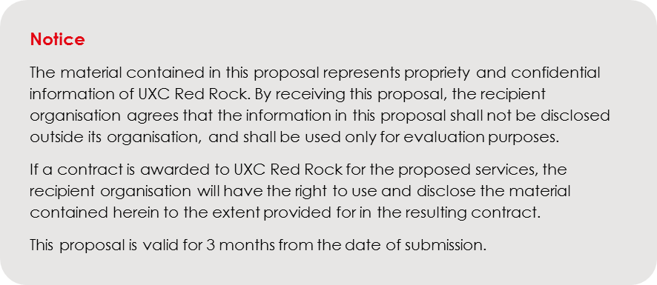

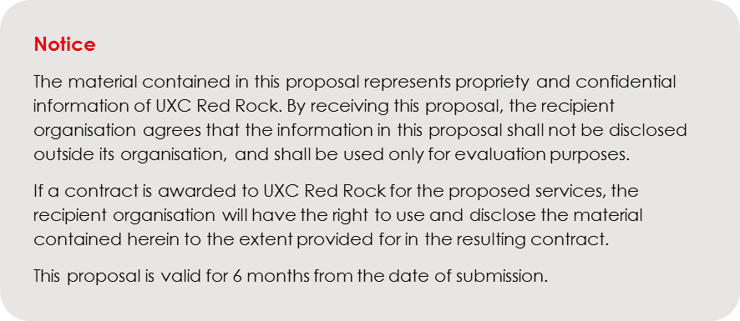

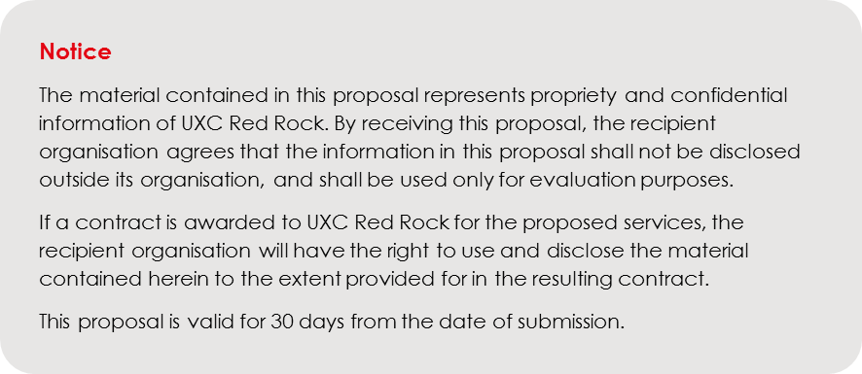

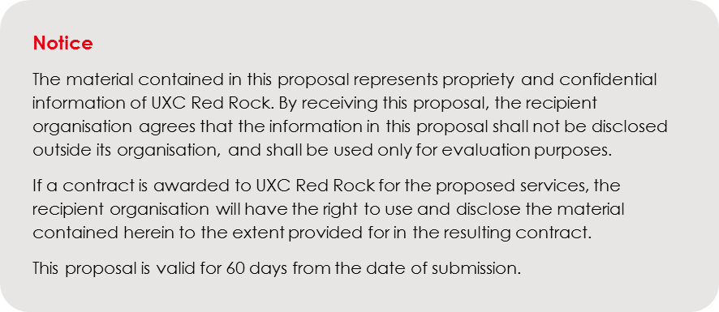

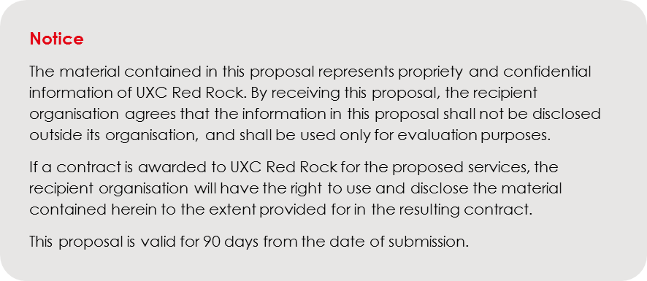

~ END OF DOCUMENT ~



ABN 59 081 356 425

[Contact name]

[Title]

email: name@uxcredrock.com

mobile: +6x xxx xxx xxx

phone: +6x x xxx xxxx

fax: +6x x xxx xxxx

physical: Street Address

post: PO Address

virtual: www.uxcredrock.com